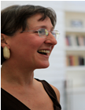Charisse Basquin, D.C.

Charisse received her doctorate in chiropractic in 1986 and has over 30 years combining craniosacral therapy with manipulative therapy to facilitate the release of trauma held in the body. She worked with midwives in Alaska as a midwifery assistant and whilst working with families during the peri-natal period, she realized how this vulnerable and empowering time is directly related to our ability to maintain healthy relationships and have a sense of belonging throughout our lives.

She worked through the Scottish Police with ex-offenders and currently has a private practice in Scotland working with individuals and families, she facilitates Birth Process Workshops and co-facilitates a training for professionals in Pre and Perinatal Therapy. All with the focus of enhancing bonding and transforming early traumatic imprints.

Charisse provides deeply intuitive presence and experience in the areas of contact, connection, creating boundaries to enhance meaningful connection with others without losing self.

‘Our deepest fear is not that we are inadequate. Our deepest fear is that we are powerful beyond measure. It is our light, not our darkness, that most frightens us. We ask ourselves, who am I to be brilliant, gorgeous, talented, and fabulous? Actually, who are you not to be?’
Marianne Williamson
(On the occasion of Nelson Mandela’s
inaugural speech)

An intimate group setting for a personal process - helping you to be who you really are.

30 Oct – 2 Nov 2020
France
Cost: 475 Euros

Contact
Charisse Basquin
earlyimprintsuk@gmail.com

HEALING EARLY IMPRINTS
A Personal Process

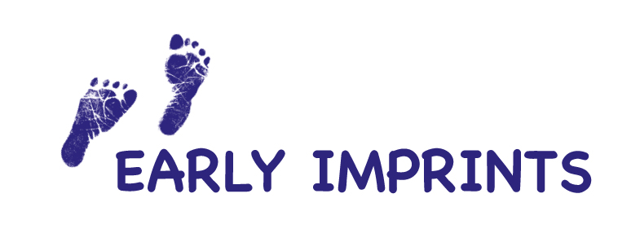
Healing Early Imprints

Healing Early Imprints offers you a personal process to boost well being, self empowerment and freedom.

Through a safely guided exploration of early experiences, you’ll deepen your self-understanding and discover new ways of engaging with yourself and others.

The experiential nature of the workshop and the emphasis on safety and spaciousness allows you to go at your own pace, and experience profound transformation.

What are early imprints?

Early experiences shape the development of the brain and nervous system. From conception to the age of 3, many neural pathways are formed, laying down patterns in the relational areas of the brain. This is the foundation for bonding and attachment.

Memories and styles of relationship are woven into your body. They are like ‘imprints’ in your nervous system and continue to affect your behavior, relationships, self-esteem and expectations, as well as your physical and emotional wellbeing.

The ideal is for a child to feel nurtured, loved, accepted and affirmed. Where there has been stress, upset or poor bonding, resulting imprints may make it difficult for a person, in adulthood, to manage stress or to fully enter into relationship.

Creating new imprints

The nervous system, including the brain, is malleable, and can develop new pathways throughout life in response to new experiences.

It is possible to create new imprints that are conducive to relational well being, health, and personal growth. The process tends to be deeply healing and empowering.

What happens on a workshop?

Using a sensitive process that taps into the body-held memories of your early life, it is possible to access and alter patterns that inhibit full self expression or cause you difficulties today. You can create new imprints.

Each workshop has 4-6 participants.

Each participant receives an individual session that varies in length from 90 minutes to three hours. The group structure offers the opportunity for exploration beyond what may be possible within the context of one to one work.

The group setting can mirror original family dynamics, which aids exploration of early influences, and because the group is supportive, both exploration and healing can take place in a safe and therapeutic way.

Requirements
To support this level of exploration, each participant is required to have engaged in some of their own therapeutic work, and have access to follow up therapeutic support after the workshop.
To support clarity and safety, each participant is also required to refrain from the use of recreational and spiritual drugs, including alcohol, for 24 hours prior to and during the course of the workshop.
Participants agree to attend the entire workshop and agrees to keep evenings free from commitments.

Some reflections
“For the first time I feel like I belong.”
“I’ve found my voice, and am more able to say what I truly mean.”
“I feel more connected to my heart.”
“After 25yrs of being a psychotherapist I have found the missing piece.”

